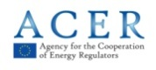
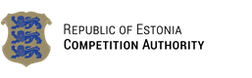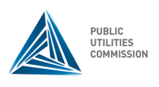
18th Baltic Electricity Market Forum
IG meeting

Thursday, 6th November 2014
Vilnius, Lithuania

National Commission for Energy Control and Prices
Public Hearings Room (III floor)
Verkių st. 25C-1, LT-08223 Vilnius
www.regula.lt

Hosted by the
National Commission for Energy Control and Prices of the Republic of Lithuania

AGENDA

12:30 – 13:00 Welcome coffee

13:00 – 14:00 Common coordinated cross-border capacity calculation and allocation procedure in the Baltic region
Lead by Alnis Balins, Latvian TSO

14:00 – 14:30 High prices in NPS Elspot market: reasons and experience sharing of investigations of possible REMIT breaches. Data collection by REMIT
Lead by Valters Kalme, Latvian NRA

14:30 – 15:00 Balancing energy study results and preparation for the implementation of Network Code on Energy Balancing
Lead by Robertas Staniulis, Lithuanian TSO

15:00 – 15:15 Coffee break

15:15 – 15:45 Congestion rent and its usage
Lead by Marilin Tilkson, Estonian NRA

15:45 – 16:15 Projects of Common Interest
Lead by Dace Bite, Latvian NRA

16:15 – 16:45 BEMIP implementation update
Lead by Aistija Zubaviciute, Lithuanian NRA
16:45 – 17:00 Future topics and end

